AI – LAB 1

Find a route between different connected cities

(Solve the task using recursion)

The interaction of the program related to 3rd question with user may be as follows:

Please enter filename storing a network: pb.txt

Enter the name of starting city: Kasur

Enter the name of destination: Bakhar

Path is Kasur -> Sahiwal -> Jhang -> . . . -> Bhakar

Or Kasur is not a valid city, please re-enter options,

Or Bakhar is not a valid city, please re-enter options,

Or there is not path from Kasur to Bakhar, please re-enter option.

File pb.txt may have data for picture like

8

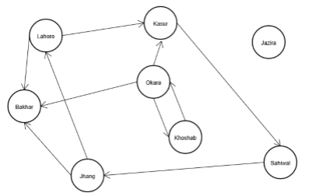0 Lahore, 2 1 3

1 Kasur, 1 7

2 Jazira, 0

3 Bakhar, 0

4 Okara, 3 1 3 6

5 Jhang, 2 0 3

6 Khosab, 1 4

7 Sahiwal, 1 5

**Explaination**: First line consists of the number of cities following by their details one per line. Starting integer on a line is the index no (consecutive integers starting from 0) of a city followed by name and a comma (,). After comma an integer denotes number of outgoing connections following by the indices of those cities.

Read file data into a list of type CityData.

**class CityData**

{

string name;

int outConCount;

int *outCons;

bool seen; // initialize as false and will be used by main algo

int predecessor; // initialize as -1 (a sentinel value) and will be used by main algo …

};

**Main algorithm:**

Search starting city, if found mark it seen, push its index into a stack

while stack is not empty

{

cc = pop index from stack

if cc is index of destination

{

job done: path is found, display it using predecessor data

}

else {

for its (cc) unseen outCons

mark them as seen,

set cc as their predecessor

and push them into the stack

}

}

If Stack is empty: Path not found, output not found message

You must complete the following using recursion (using stack, its optional)